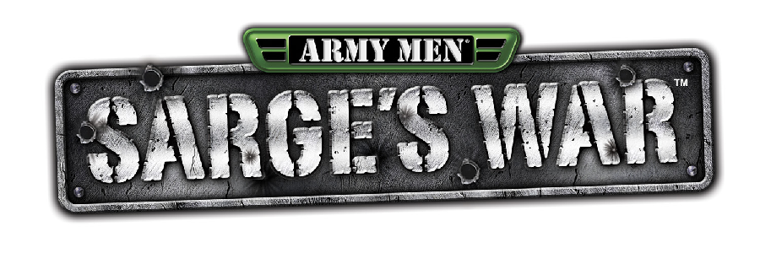

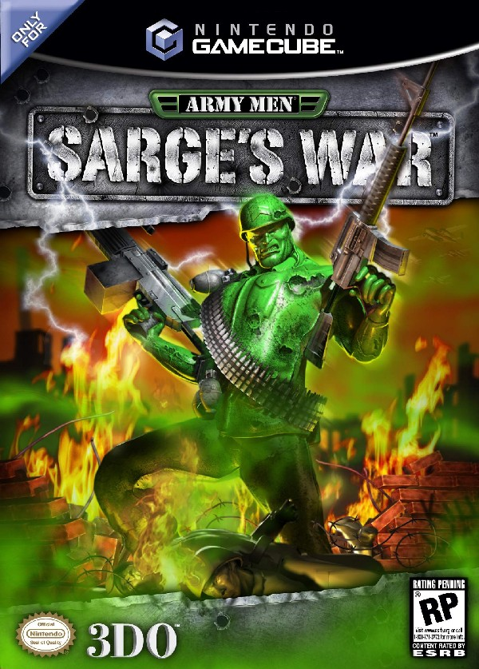
Title: Army Men®: Sarge’s War™
Publisher: The 3DO Company
Platform: Nintendo GameCube™
Planned Release Date: Q4 2002
ESRB Rating: RP (Teen expected)
Genre: Action-Shooter
Peripherals: Nintendo GameCube Controller
# of Players: 1-2
Target Audience: Males 13-17
SKU Code: 5313-01-031
UPC: 7 90561 53131 9

Sarge wages an All-Out Assault as Army Men storms the Nintendo GameCube system.

SUMMARY:
Sarge is back and he’s declared a one-man war against the Tan Army, in this all-new Action-Shooter on the Nintendo GameCube. His entire squad has been melted, his nation stands on the brink of destruction, and his enemy has possession of the most diabolical weapon ever created. Join Sarge as he avenges the death of his fallen heroes and exacts his revenge on the Tan army, fighting his way through ravaged war-torn battlefields and across immense kitchen counter tops in an all-out battle of total plastic destruction!

HIGHLIGHTS AND KEY FEATURES:

- “Dynamic Melting Effects”- characters will take visible damage such as gaping exit wounds and missing limbs, and will retain damage throughout gameplay
- Photo-realistic graphics and art in varied “Our World” and “Their World” settings
- Grittier, edgier Sarge character with an all-new, butt-kicking attitude
- Screen relative control and camera system that features movie-like camera usage
- Over 600 fluid motion-capture animations, including incredible deaths and Hollywood -style combat moves
- Enemy A.I. will seek cover, hunt, patrol, outflank, attack, and avoid the player – creating realistic and unpredictable tactical challenges for the player in every mission!
- 2 multiplayer modes- Death Match and Capture the Flag
- 6-month print campaign in top gaming books

Sales Contact Information:
Sales Phone: (650) 385-3152
Sales Fax: (650) 385-3179

